**Semester 1 (Unit 3) Examination, 2016**

**Question/Answer Booklet**

**MATHEMATICS APPLICATIONS**

**Section One: Calculator-free**

Student Name/Number: ______________________________________________

Teacher Name: ______________________________________________

**Time allowed for this section**

Reading time before commencing work: five minutes

Working time for this section: fifty minutes

**Materials required/recommended for this section**

**To be provided by the supervisor:** This Question/Answer Booklet

Formula Sheet

**To be provided by the candidate:**

Standard items: pens (blue/black preferred), pencils (including coloured), sharpener,

correction fluid/tape, eraser, ruler, highlighters

Special items: nil

**Important note to candidates**

No other items may be taken into the examination room. It is **your** responsibility to ensure that you do not have any unauthorised notes or other items of a non-personal nature in the examination room. If you have any unauthorised material with you, hand it to the supervisor **before** reading any further.

**Structure of this paper**

|  |  |  |  |  |  |
| --- | --- | --- | --- | --- | --- |
| Section | Number of questions available | Number of questions to be answered | Working time (minutes) | Marks available | Percentage of exam |
| Section One: Calculator-free | 6 | 6 | 50 | 50 | 35 |
| Section Two: Calculator-assumed | 10 | 10 | 100 | 105 | 65 |
|  | | | | | 100 |

**Instructions to candidates**

1. The rules for the conduct of these exams are detailed in the *College assessment policy*. Sitting this examination implies that you agree to abide by these rules.
2. Write your answers in this Question/Answer Booklet.

3. You must be careful to confine your responses to the specific questions asked and to

follow any instructions that are specific to a particular question.

1. Spare pages are included at the end of this booklet. They can be used for planning your responses and/or as additional space if required to continue an answer.
   * Planning: If you use the spare pages for planning, indicate this clearly at the top of the page.
   * Continuing an answer: If you need to use the space to continue an answer, indicate in the original answer space where the answer is continued, i.e. give the page number. Fill in the number of the question that you are continuing to answer at the top of the page.
2. **Show all working clearly.** Your working should be in sufficient detail to allow your answers to be checked readily and for marks to be awarded for reasoning. Incorrect answers given without supporting reasoning cannot be allocated any marks. For any question or part question worth more than two marks, valid working or justification is required to receive full marks. If you repeat any question, ensure that you cancel the answer you do not wish to have marked.
3. It is recommended that you **do not use pencil**, except in diagrams.
4. The Formula Sheet is **not** to be handed in with your Question/Answer Booklet.

**Section One: Calculator-free 35% (50 Marks)**

This section has **6** questions. Answer **all** questions. Write your answers in the spaces provided.

Spare pages are included at the end of this booklet. They can be used for planning your responses and/or as additional space if required to continue an answer.

* + Planning: If you use the spare pages for planning, indicate this clearly at the top of the page.
  + Continuing an answer: If you need to use the space to continue an answer, indicate in the original answer space where the answer is continued, i.e. give the page number. Fill in the number of the question that you are continuing to answer at the top of the page.

Suggested working time: **50 minutes**.

**Questions commence on the next page**

**Question 1 (5 marks)**

The president of a rural shire council wants the worst of the litter removed from the verges of the roads of the shire. To prepare for the cleanup, two employees are asked to drive along each road and record, on a map, the locations that need the greatest attention.

The map of the shire roads is represented by the network below, with the road intersections shown as labelled vertices. The position of the main town is also denoted by a vertex and is marked with the letter, T.

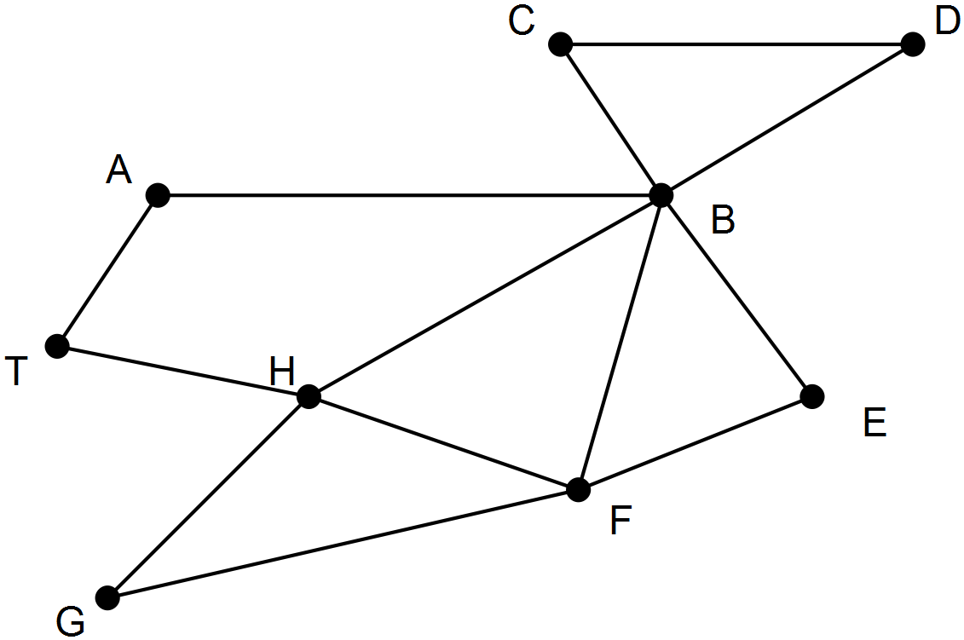

(a) The workers want to leave from and return to the main town, driving along each road in the shire only once. One of the workers can identify that such a route does exist just by looking at the map and studying the intersections.

Describe a method the worker could have used to arrive at this decision. (2 marks)

(b) Name the type of trail described in part (a) (1 mark)

(c) Identify a route that satisfies the conditions in part (a). (2 marks)

**Question 2 (6 marks)**

After reading in the paper about the increased rate of criminal activity in beach suburbs, Freda decided to investigate some statistics for a popular beach suburb. She used data from the website for the Western Australia Police and examined the relationship between the number of assaults and the number of burglaries each month. Using a spreadsheet package she produced the following display.



(a) Describe the strength of the linear relationship between the two variables. Justify your conclusion. (2 marks)

(b) The linear relationship between the two variables is described by the equation provided.

(i) What does this equation indicate is the approximate number of burglaries in a given month when there are no assaults? (1 mark)

(ii) What does this equation indicate would be the rate of change in the number of burglaries as the number of assaults increase? (3 marks)

**Question 3 (9 marks)**

Over the years, a regional authority has found that the presence of a supermarket, a bank, a service station and a hotel was a good indicator of a country town’s well-being.

Below is shown a section of the table containing this information for some of the country towns. The towns are not named. They are denoted by numbers.

|  |  |  |  |  |  |
| --- | --- | --- | --- | --- | --- |
|  |  | Service provided | | | |
|  | Bank  (B) | Supermarket (M) | Service Station  (S) | Hotel  (H) |
|  | 7 | Yes | Yes | Yes | Yes |
| Towns | 8 | No | Yes | Yes | No |
|  | 9 | No | No | Yes | Yes |

(a) Display the information in the table as a bipartite graph. (3 marks)

(b) Looking at this bipartite graph of the three towns, an officer at the regional authority commented that the graph was planar. (3 marks)

(i) When is a graph planar?

(ii) Draw the bipartite graph again, showing that it is planar.

(c) The officer also commented that if Town 9 had one more of the service providers, the bipartite graph would no longer be planar. (3 marks)

(i) To which of the service providers was the officer referring?

(ii) Draw the bipartite graph again showing why with this additional piece of information displayed on the graph, it is no longer a planar graph?

**Question 4 (11 marks)**

Consider the following graph

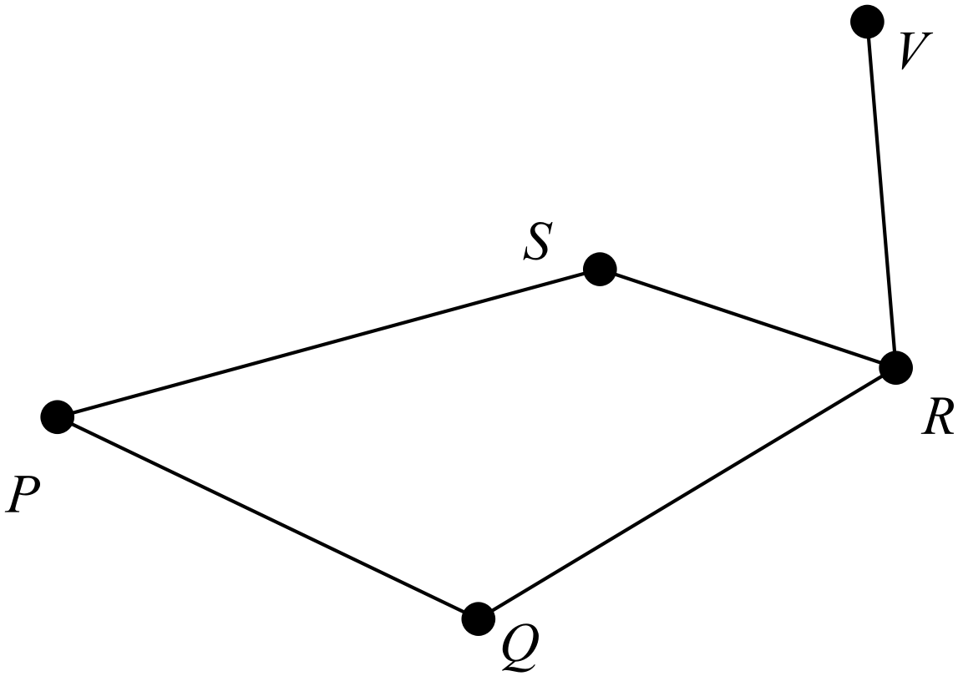

(a) Which of the types of graphs listed below describe the graph above?

Circle the letter(s) next to the type(s) that you select.

(A) a simple graph (B) a digraph (C) a planar graph

(D) a connected graph (E) a complete graph (F) a weighted graph

(3 marks)

(b) Explain why the graph above is NOT an Eulerian graph. (2 marks)

(c) Show, however, that Euler’s Rule is true for the graph.(2 marks)

(d) Explain why edge PQ is not a bridge. (2 marks)

(e) Complete the following sentence to make it a true statement.

The degree of vertex R is ........... because .................................................................

.......................................................................................................................................

(2 marks)

**Question 5 (11 marks)**

The water tank near the house on a farm has a capacity of 4000 litres and needs to be filled regularly. There is a gauge on the side to show the volume of water in the tank.

On Tuesday at 5:00am, Alice turned on the pump used to transfer water into the tank. The pump delivers water at the rate of 200 litres per hour.

(a) Complete the table below. (3 marks)

|  |  |  |  |  |  |
| --- | --- | --- | --- | --- | --- |
| Number of hours pump was working | 1 | 2 | 3 | 5 |  |
| Volume of water in the tank (in litres) |  | 560 |  |  | 1360 |

(b) What was the volume of water in the tank at 8:00am? (1 mark)

(c) If $T_{2}$ represents the volume of water in the tank after the pump has been working for

2 hours and $T_{2}$ = 560 , write a recursive formula to determine the volume. (2 marks)

(d) Clearly, a relationship exists between the ”Number of hours the pump was working ” and the “Volume of water in the tank”. Is the relationship linear or exponential? Explain your choice. (2 marks)

(e) How much water was in the tank at 2:00pm? (2 marks)

(f) How long was the pump working last Tuesday for the volume of water in the tank to reach 3760 litres? (1 mark)

**Question 6 (8 marks)**

A Year 12 student was trying to locate the shortest Hamiltonian circuit for a postal van to visit four connected villages, W, X, Y and Z and drew a type of “tree diagram” as shown below. The circuit had to start at village W. Use the student’s diagram, where the distances between villages are given in kilometres, to answer the questions below.

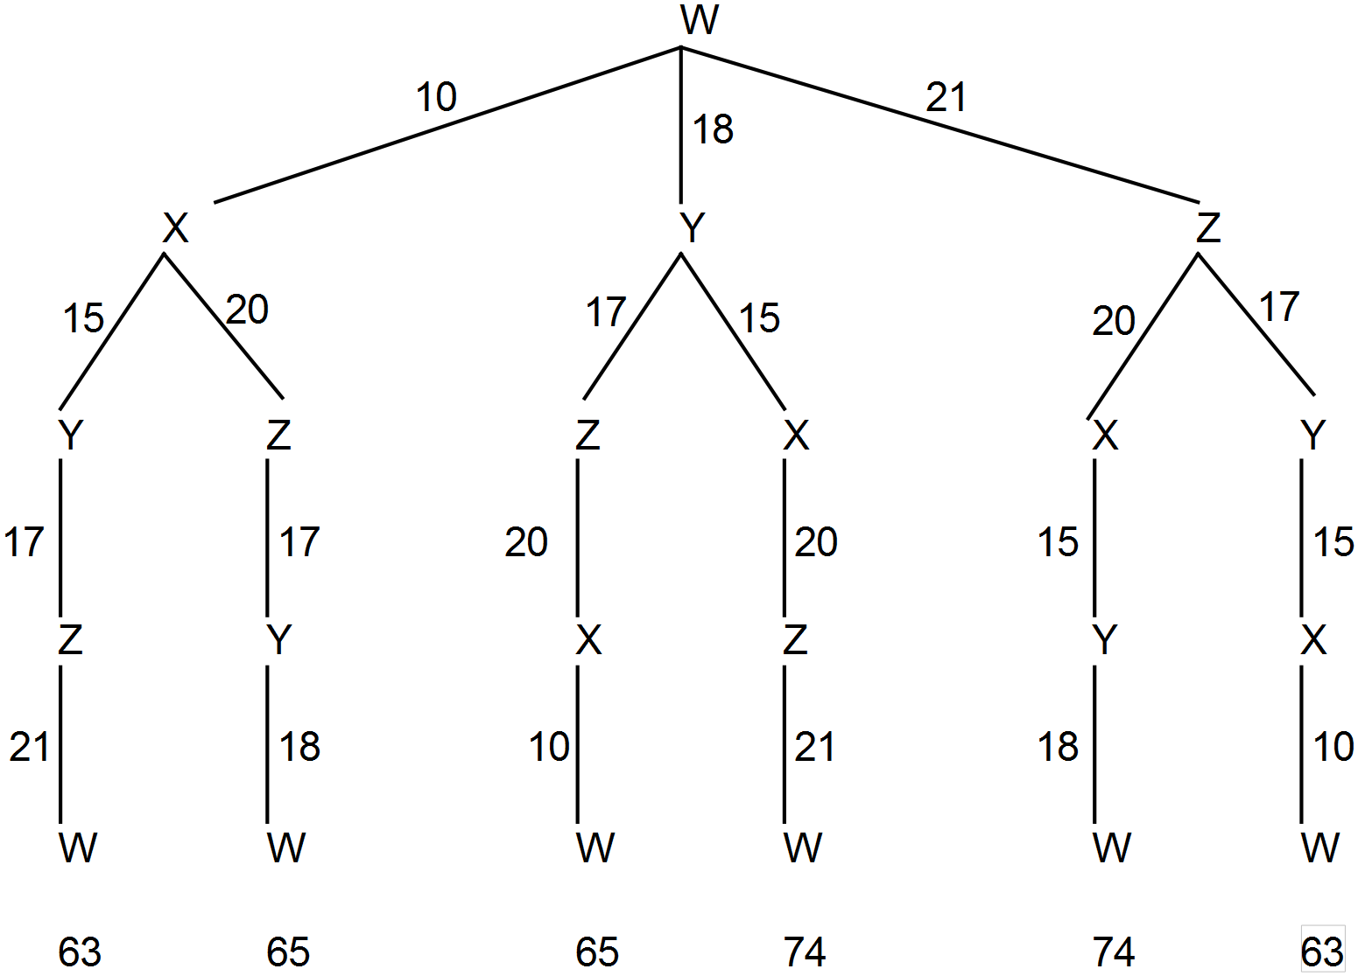

(a) How many different Hamiltonian circuits were available for the postal van? (1 mark)

(b) Identify the shortest Hamiltonian circuit and determine its length. (2 marks)

(c) What features will a path have if it is also a Hamiltonian circuit? (2 marks)

(d) Draw the weighted graph represented by the student’s tree diagram. (3 marks)

**End of Questions**

Additional working space

Question number: __________________

**Acknowledgements**

© MAWA, 2016

This examination is Copyright but may be freely used within the school that purchases this licence.

* The items that are contained in this examination are to be used solely in the school for which they are purchased.
* They are not to be shared in any manner with a school which has not purchased their own licence.
* The items and the solutions/marking keys are to be kept confidentially and not copied or made available to anyone who is not a teacher at the school. Teachers may give feedback to students in the form of showing them how the work is marked but students are not to retain a copy of the paper or marking guide until the agreed release date stipulated in the purchasing agreement/licence.

*Published by The Mathematical Association of WA*

*12 Cobbler Place, MIRRABOOKA 6…*